**Travel Air**

Report submitted in partial fulfillment of the requirements for the   
award of the Degree of

**BACHELOR OF COMPUTER APPLICATION**

**( GAME AND MOBILE SOFTWARE DEVELOPMENT )  
of  
CMR UNIVERSITY**

*****By*  
**Ashwin Cherian Joseph  
Reg. No. 17BCAG010**

Under the guidance of  
**Tejas S  
Faculty**

**CMR UNIVERSITY**

**CMR UNIVERSITY**2017–2020

**DECLARATION**

I hereby declare that the internship work entitled “*Travel Air”* submitted to the School of Science Studies, CMR University, Bangalore, is a record of an original work done by me under the guidance of *“Tejas S, BCA (Game and Mobile software development)”* and this internship report is submitted in the partial fulfilment of the requirements of fourth semester Examinations.

I also declare that this project is the outcome of my own efforts and that it has not been submitted to any other university or Institute for the award of any other degree or Diploma or Certificate.

**Place: Bangalore Name: Ashwin Cherian Joseph**

**Date: Register Number: 17BCAG010**

**Table of Contents**

1. **Objective 2**
2. **Audience 2**
3. **The Experience 2**
4. **App Usage 2**
   1. **Example**
   2. **Example**
   3. **Example**
5. **Introduction 2**
6. **Targeted Platforms 3**
7. **Features 3**
   1. **Core Features**
   2. **Tabbed Layout**
   3. **Search**
8. **Special Features 4**
9. **Similarities 4**
   1. **Previous Version**
   2. **Current Version**
   3. **Future Version**
10. **Screenshots 6**
11. **Conclusion 21**
12. **Bibliography 22**

**1**

**Objective**

**The sole purpose of the app is for users to book Air tickets. Using this application you can select from and to destination and select the flight seeing the ticket fares. Users can book flight in just a few taps.**

**Audience**

**The potential audience of the application consists of all ages. There are no age restrictions in terms of content or any other aspect for that matter.**

**The Experience**

**The key experience of the user would be the fact that he/she can easily book flights. The user will be able to see all the flights going to that destination and choose the flight that comes under their budget.**

**App Usage**

**Example 1: If the user wants to see the flights on that particular date he/she can see them easily**

**Example 2: If the user wants to compare the flight fares he/she can do that easily**

**Example 3: If the user wants to see all the recent and upcoming trips**

**Introduction**

**News App uses the feature of real-time databases of the flight details which are called from the SQL Database. The application automatically retrieves data and adds to a list of data in the app when it gets updated in the sql database. The app has no age restrictions but is well suited for people who wants to buy flight tickets for a cheap price.**

**2**

**Targeted Platforms**

**The Travel Air app is currently being built with only android support, although a version for iOS is to be expected within the next year. The app is supported on almost all android devices and requires internet for real-time updates.**

**Features**

1. **Core Feature**
   * **The core feature of the application is to display the flight details to the users and making them able to book the flight. Users have to create a user either with their email ID or using Google Sign In support. The app collects data from flight SQL database and adds it to the list of data on the app.**
2. **Seat Selection**
   * **Another important feature of the app is the ability of the users to select flight seats depending on the user’s wishes. They can select the no of seats (Max : 4) and then select the desired seats in the plane. They can see the selected seats numbers in the ticket later.**
3. **My Trips**
   * **This feature allows the users to see their individual booked flights in an order of recently booked. This would potentially bring more users over to the app and increase the ease of access for the users.**

**3**

**Similarities**

1. **Previous Version of this app**
   * **There exist multiple versions of Travel Air similar to this one but are loaded with ads and can be sometimes(Most times) biased.**
2. **Current Version of this app**
   * **Currently we can use the app to stay up-to-date on flight details without bias and no ads.**
3. **Future Version of this app**
   * **The coming versions of the app should be expected to have the following features implemented:**
     1. **Search bar**
     2. **Notifications**
     3. **Sort by option**
     4. **Fingerprint Authentication**

**Special Features**

1. **Register Option**

**The app allows you to register a new account. If you want to book a flight ticket, it is mandatory to have a registered account in the app.**



1. **Google Sign In Option**

**This feature allows you to register a new account in Travel Air using your Google Account. This is achieved using Google O-Auth feature from Google Firebase.**

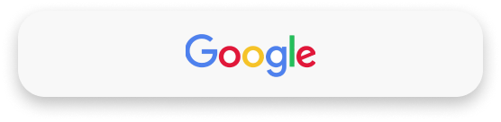

**4**

1. **Seat Selection**

**This App allows you to select your preferred seat in the selected flights. You can select a maximum of 4 seats per booking. Individual seat numbers will be displayed in the ticket.**

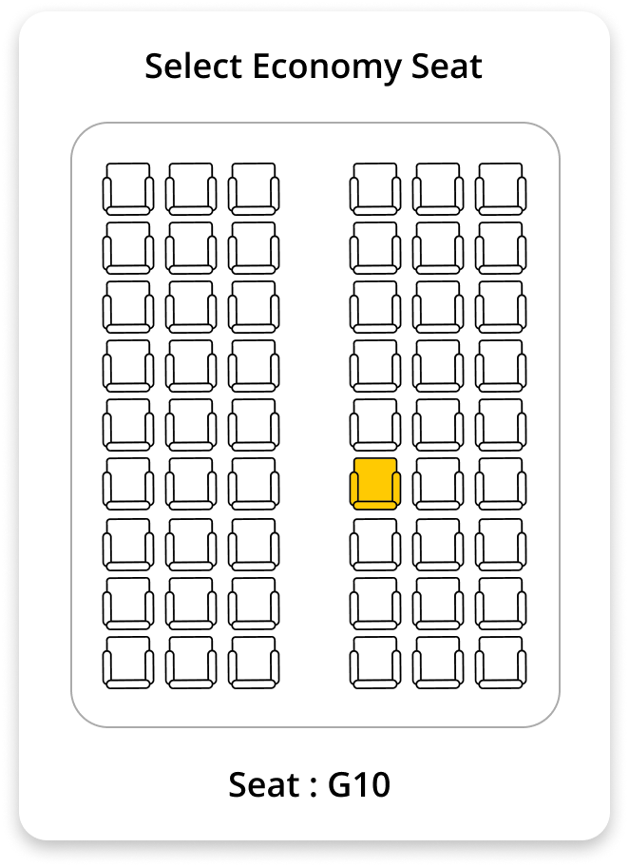

**5**

**Screenshots**

**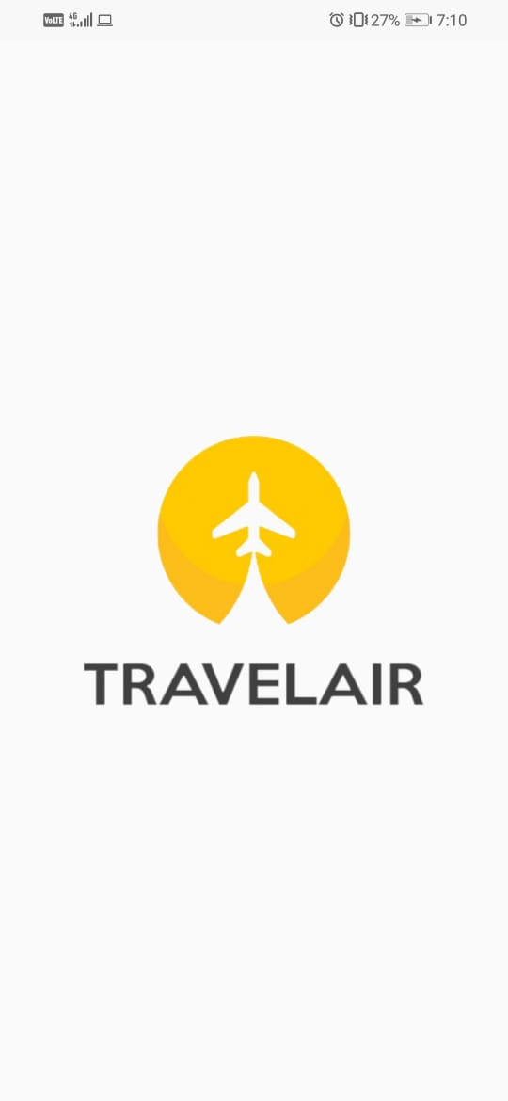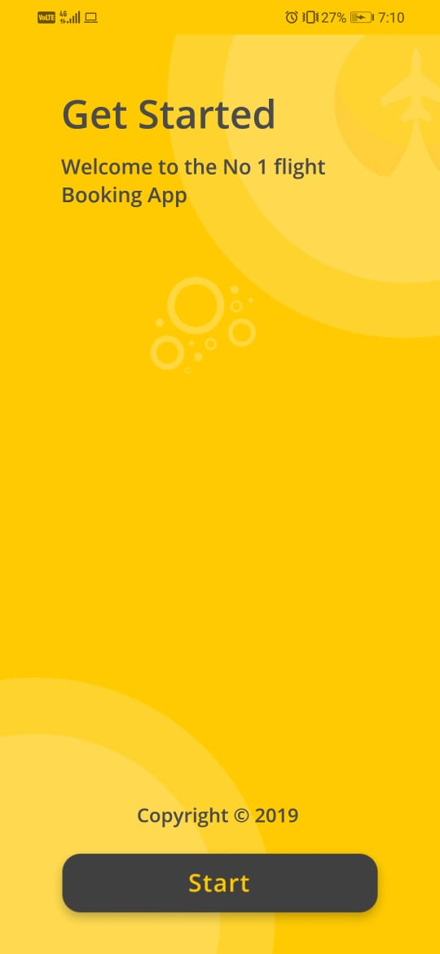  
  
  
  
  
  
6**

**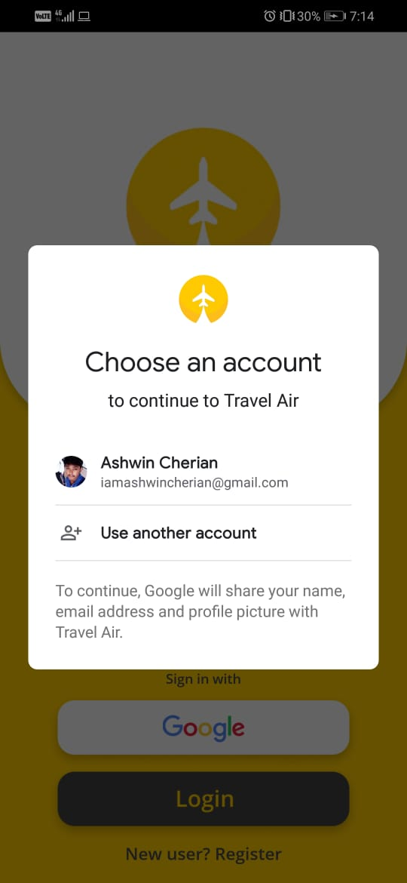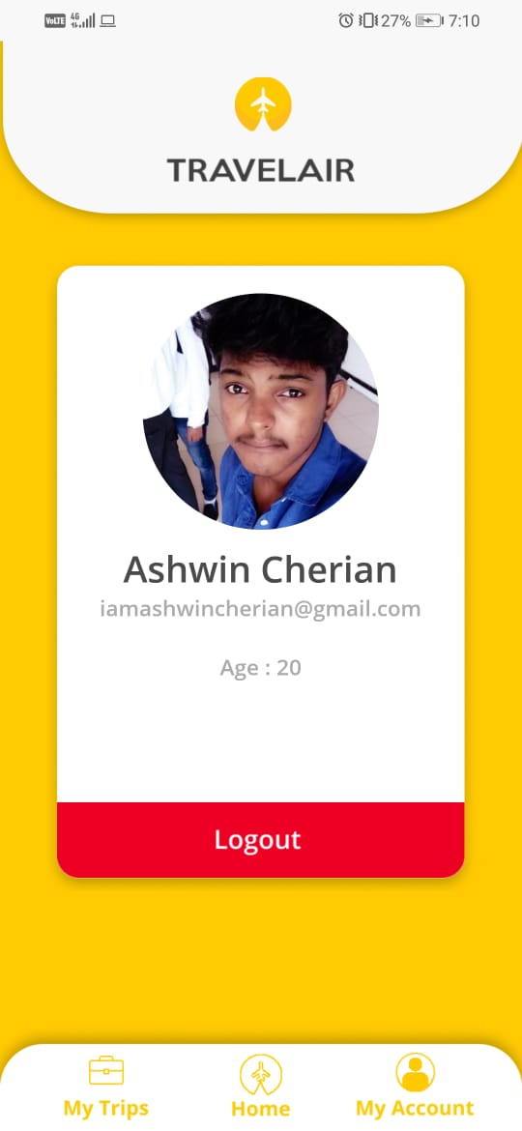  
  
  
  
  
  
  
  
7  
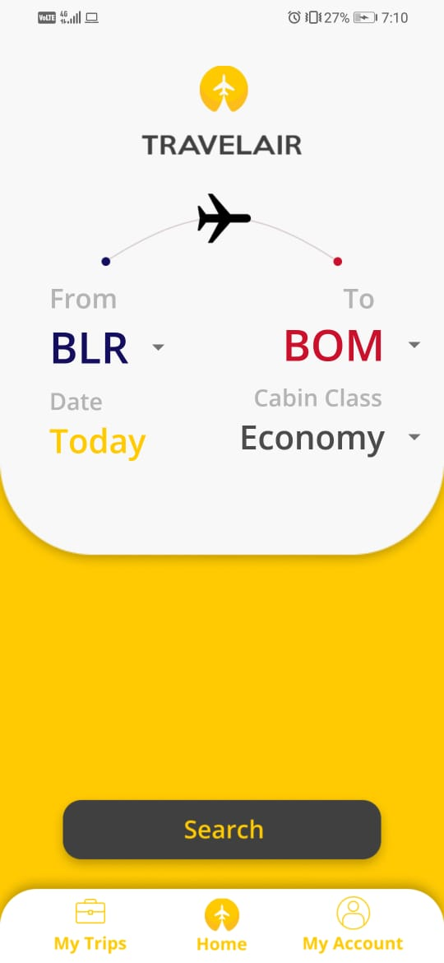 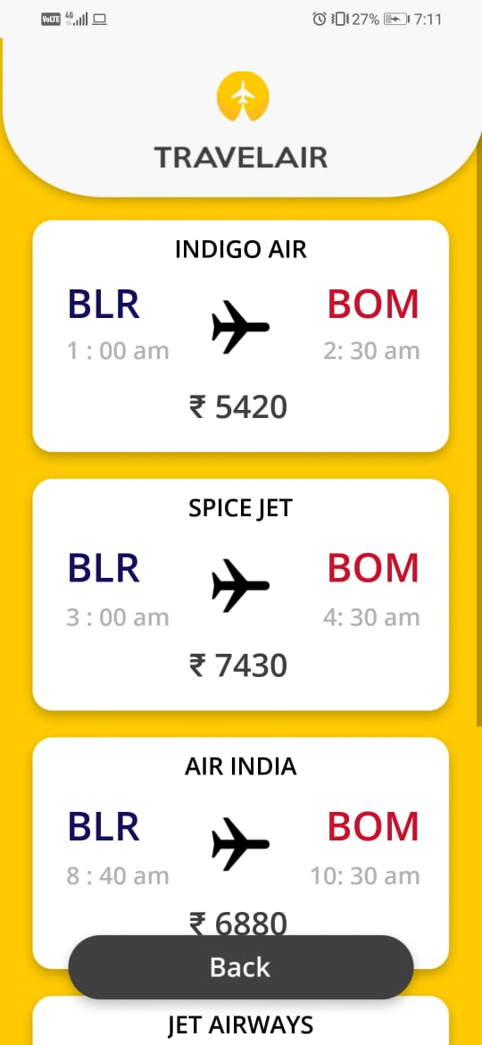  
  
  
  
  
  
  
  
8  
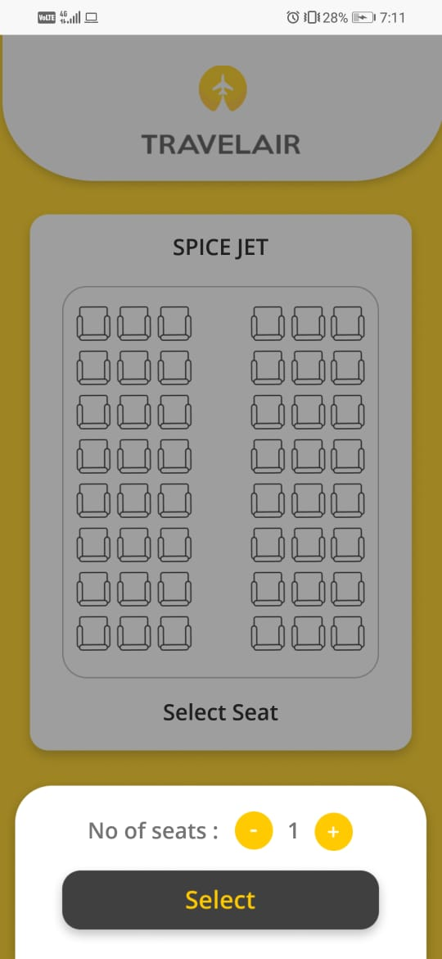 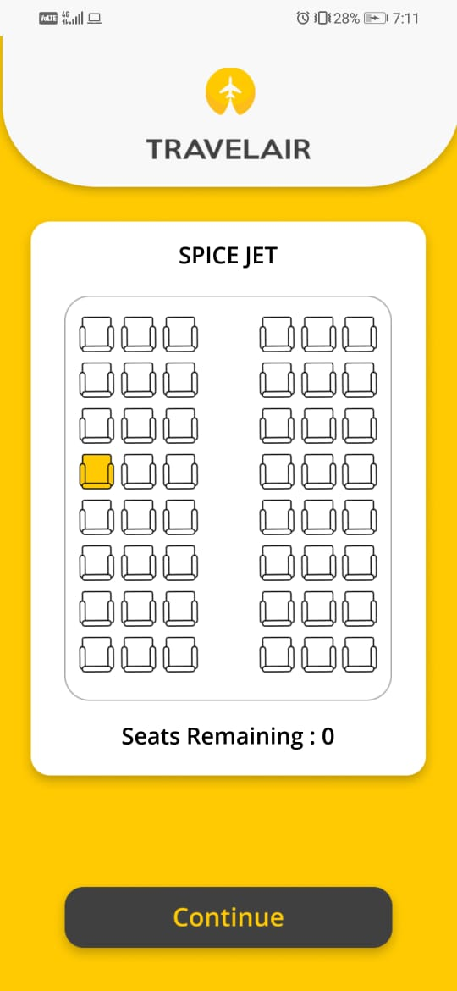  
  
  
  
  
  
  
  
  
9**

**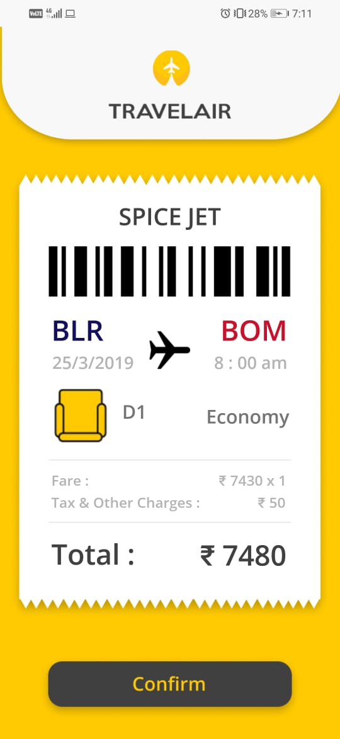  
  
  
  
  
  
  
  
  
10**

**SQL DATABASE CODE**

**package com.example.travelair;**

**import android.content.ContentValues;**

**import android.content.Context;**

**import android.database.Cursor;**

**import android.database.sqlite.SQLiteDatabase;**

**import android.database.sqlite.SQLiteOpenHelper;**

**public class DBHelper extends SQLiteOpenHelper {**

**public static final String DATABASE_TABLE = "travelAir";**

**public static final String TABLE_NAME_USERS=("users_table");**

**public static final String TABLE_MY_TRIPS=("trips_table");**

**public static final String COL_1=("id");**

**public static final String COL_2=("name");**

**public static final String COL_3=("age");**

**public static final String COL_4=("email");**

**public static final String COL_5=("pass");**

**public static final String COL_6=("phone");**

**public static final String COL_7=("accID");**

**public DBHelper(Context context) {**

**super(context, DATABASE_TABLE, null,1);**

**}**

**@Override**

**public void onCreate(SQLiteDatabase db) {**

**11**

**db.execSQL("create table "+ TABLE_NAME_USERS +" (id integer primary key autoincrement, name text, age text, email text, pass text, phone text, accID text)");**

**db.execSQL("create table "+ TABLE_MY_TRIPS +" (id integer primary key autoincrement, flight_name text, flight_from text, flight_to text, flight_date text, flight_time text, flight_seat1 text, flight_seat2 text, flight_seat3 text, flight_seat4 text, flight_class text, user_id text)");**

**}**

**@Override**

**public void onUpgrade(SQLiteDatabase db, int oldVersion, int newVersion) {**

**}**

**public boolean insertData(String name,String age,String email,String pass,String phone)**

**{**

**SQLiteDatabase db=this.getWritableDatabase();**

**ContentValues contentValues=new ContentValues();**

**contentValues.put(COL_2,name);**

**contentValues.put(COL_3,age);**

**contentValues.put(COL_4,email);**

**contentValues.put(COL_5,pass);**

**contentValues.put(COL_6,phone);**

**db.insert(TABLE_NAME_USERS,null,contentValues);**

**return true;**

**12**

**public boolean insertTrips(int id,String name,String from,String to,String date, String time, String seat1,String seat2,String seat3,String seat4, String cclass)**

**{**

**SQLiteDatabase db=this.getWritableDatabase();**

**ContentValues contentValues=new ContentValues();**

**contentValues.put("user_id",id);**

**contentValues.put("flight_name",name);**

**contentValues.put("flight_from",from);**

**contentValues.put("flight_to",to);**

**contentValues.put("flight_date",date);**

**contentValues.put("flight_time",time);**

**contentValues.put("flight_seat1",seat1);**

**contentValues.put("flight_seat2",seat2);**

**contentValues.put("flight_seat3",seat3);**

**contentValues.put("flight_seat4",seat4);**

**contentValues.put("flight_class",cclass);**

**db.insert(TABLE_MY_TRIPS,null,contentValues);**

**return true;**

**}**

**public boolean insertGoogleAcc(String name,String age,String email,String pass,String phone,String accID)**

**{**

**SQLiteDatabase db=this.getWritableDatabase();**

**ContentValues contentValues=new ContentValues();**

**contentValues.put(COL_2,name);**

**13**

**contentValues.put(COL_3,age);**

**contentValues.put(COL_4,email);**

**contentValues.put(COL_5,pass);**

**contentValues.put(COL_6,phone);**

**contentValues.put(COL_7,accID);**

**db.insert(TABLE_NAME_USERS,null,contentValues);**

**return true;**

**}**

**public boolean auth(String email,String pass)**

**{**

**SQLiteDatabase db =this.getReadableDatabase();**

**Cursor cur = db.rawQuery("select * from users_table where email=? and pass=?",new String[]{email,pass});**

**if(cur.getCount()>=1)**

**{**

**return true;**

**}**

**else**

**{**

**return false;**

**}**

**}**

**public Cursor getAllData() {**

**SQLiteDatabase db=this.getWritableDatabase();**

**Cursor res=db.rawQuery("select * from "+TABLE_NAME_USERS,null);**

**14**

**return res;**

**}**

**public Cursor setUserData(String email){**

**SQLiteDatabase db=this.getWritableDatabase();**

**Cursor res=db.rawQuery("select * from "+TABLE_NAME_USERS + " where email=?",new String[]{email});**

**return res;**

**}**

**public boolean check(String id){**

**SQLiteDatabase db =this.getReadableDatabase();**

**Cursor cur = db.rawQuery("select * from users_table where accID=?" ,new String[]{id});**

**if(cur.getCount()>=1)**

**{**

**return true;**

**}**

**else**

**{**

**return false;**

**}**

**}**

**public Cursor getTrip(String id){**

**SQLiteDatabase db=this.getWritableDatabase();**

**Cursor res=db.rawQuery("select * from "+ TABLE_MY_TRIPS + " where user_id=?",new String[]{id});**

**15**

**return res;**

**}**

**}**

**PREFERENCE CODE**

**package com.example.travelair;**

**import android.content.Context;**

**import android.content.SharedPreferences;**

**import android.preference.PreferenceManager;**

**public class SaveSharedPreference**

**{**

**static final String PREF_USER_EMAIL= "email";**

**static final String PREF_USER_PHONE= "phone";**

**static final String PREF_USER_NAME= "name";**

**static final String PREF_USER_AGE= "age";**

**static final String PREF_USER_ID= "id";**

**static SharedPreferences getSharedPreferences(Context ctx) {**

**return PreferenceManager.getDefaultSharedPreferences(ctx);**

**}**

**public static void set(Context ctx, String name, String age, String email, String phone, String id)**

**{**

**16**

**SharedPreferences.Editor editor = getSharedPreferences(ctx).edit();**

**editor.putString(PREF_USER_EMAIL, email);**

**editor.putString(PREF_USER_PHONE, phone);**

**editor.putString(PREF_USER_NAME, name);**

**editor.putString(PREF_USER_AGE, age);**

**editor.putString(PREF_USER_ID, id);**

**editor.commit();**

**}**

**public static String getEmail(Context ctx)**

**{**

**return getSharedPreferences(ctx).getString(PREF_USER_EMAIL, "");**

**}**

**public static String getId(Context ctx)**

**{**

**return getSharedPreferences(ctx).getString(PREF_USER_ID, "");**

**}**

**public static String getName(Context ctx)**

**{**

**return getSharedPreferences(ctx).getString(PREF_USER_NAME, "");**

**}**

**public static String getAge(Context ctx)**

**{**

**return getSharedPreferences(ctx).getString(PREF_USER_AGE, "");**

**}**

**17**

**public static String getPhone(Context ctx)**

**{**

**return getSharedPreferences(ctx).getString(PREF_USER_PHONE, "");**

**}**

**public static void logout(Context ctx){**

**SharedPreferences.Editor editor = getSharedPreferences(ctx).edit();**

**editor.putString(PREF_USER_EMAIL, "");**

**editor.putString(PREF_USER_PHONE, "");**

**editor.putString(PREF_USER_NAME, "");**

**editor.putString(PREF_USER_AGE, "");**

**editor.putString(PREF_USER_ID, "");**

**editor.commit();**

**}**

**}**

**My Trips Recycler View Adapter Code**

**public class myTripsAdapter extends RecyclerView.Adapter<myTripsAdapter.RecyclerViewHolder> {**

**private ArrayList name,from,to,date,time,cclass;**

**public myTripsAdapter(ArrayList name,ArrayList from,ArrayList to,ArrayList date,ArrayList time,ArrayList cclass){**

**this.name = name;**

**18**

**this.from = from;**

**this.to = to;**

**this.date = date;**

**this.time = time;**

**this.cclass = cclass;**

**}**

**@NonNull**

**@Override**

**public RecyclerViewHolder onCreateViewHolder(@NonNull ViewGroup viewGroup, int i) {**

**LayoutInflater inflater = LayoutInflater.from(viewGroup.getContext());**

**View view = inflater.inflate(R.layout.my_trip_item, viewGroup, false);**

**return new RecyclerViewHolder(view);**

**}**

**@Override**

**public void onBindViewHolder(@NonNull RecyclerViewHolder recyclerViewHolder, int i) {**

**String FlightName = (String) name.get(i);**

**String FlightFrom = (String) from.get(i);**

**String FlightTo = (String) to.get(i);**

**String FlightDate = (String) date.get(i);**

**String FlightTime = (String) time.get(i);**

**String FlightCclass = (String) cclass.get(i);**

**19**

**recyclerViewHolder.flightNameText.setText(FlightName);**

**recyclerViewHolder.fromText.setText(FlightFrom);**

**recyclerViewHolder.toText.setText(FlightTo);**

**recyclerViewHolder.dateText.setText(FlightDate);**

**recyclerViewHolder.timeText.setText(FlightTime);**

**recyclerViewHolder.cclassText.setText(FlightCclass);**

**}**

**@Override**

**public int getItemCount() {**

**return name.size();**

**}**

**public class RecyclerViewHolder extends RecyclerView.ViewHolder{**

**TextView flightNameText, fromText, toText, dateText, timeText, cclassText;**

**public RecyclerViewHolder(@NonNull View itemView) {**

**super(itemView);**

**flightNameText = (TextView) itemView.findViewById(R.id.flightNameText1);**

**fromText = (TextView) itemView.findViewById(R.id.fromText);**

**toText = (TextView) itemView.findViewById(R.id.toText);**

**dateText = (TextView) itemView.findViewById(R.id.dateText);**

**timeText = (TextView) itemView.findViewById(R.id.timeText);**

**cclassText = (TextView) itemView.findViewById(R.id.cclassText);**

**20**

**}**

**}**

**}**

**Conclusion**

The knowledge gained from building just this one app is immense. I learnt so may new features that could be implemented in Android Studio that would never have happened if not for the project. The project has made me learn in-detail the various implementations of firebase and also ways to Beautify and display things in Android studio in ways I had not known before.

I am immensely grateful for to those who helped me do this project and learn so much and I hope I will be able to improve this application as well as my skills in development further in the coming months.

**21**

**Bibliography**

* Google ( [www.google.com](http://www.google.com) )
* Stack Overflow ( www.stackoverflow.com )
* Youtube ( [www.youtube.com](http://www.youtube.com) )
* Github ( www.github.com )

22